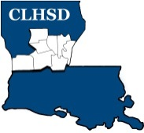
Central Louisiana Human Services District
Board Meeting Agenda
January 6, 2022

- Call to Order/Quorum
- Prayer/Pledge

- Read and Approve January 2022 Meeting Agenda (Vote)
Solicit Public Comment Requests
- Approval of Minutes (Vote)

December 2021 Board Meeting Minutes
- District Reports

  - Financial Report- (Vote) H1
  - ED Monthly Report H2

- Policy Reviews

Executive Limits:
II. D. Financial Planning/Budgeting w/corresponding procedure – Non Appropriated Funds - H3

- Board Business
  - Comments Collected on ED Performance
  - Board Development/Training Topic –Mental Health Court
  - By-Law Committee named

- Questions/Comments as Solicited

- Next Month – February

  - Executive Limits – ED
- II.E. Financial Condition and Activities w/procedure Non Appropriated Funds

  - Board Business
- Members Term Wishes send to Parishes/ Governor’s Office
- Annual Bylaws Review

  - Training Topic – Residential Treatment / Substance Use Disorder

- Announcements
Next meeting – February 3, 2022

- Adjourn (Vote)

